Project Design Phase-II Technology Stack (Architecture & Stack)

|  |  |
| --- | --- |
| **Date** | **30 October 2022** |
| **Team ID** | **PNT2022TMID40624** |
| **Project Name** | **Real time communication system powered by AI for**  **specially disabled** |
| **Maximum Marks** | **4 Marks** |

# Technical Architecture:

The Deliverable shall include the architectural diagram as below and the information as per the table1 & table 2

**Example:** Real time communication system powered by AI for specially disabled

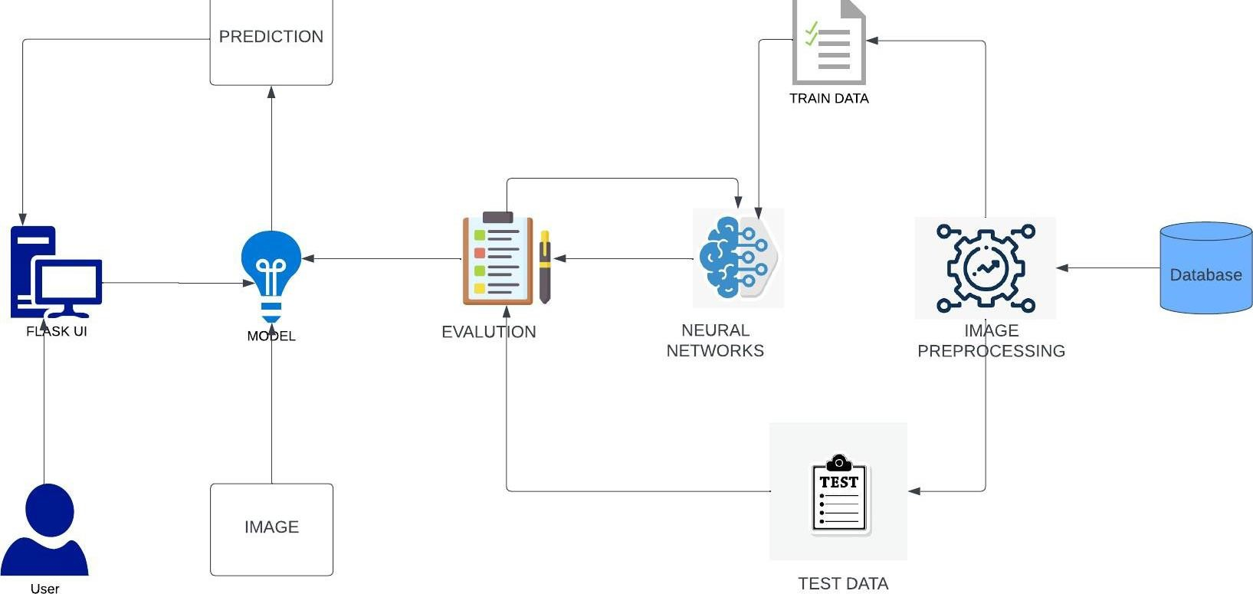

**Table-1 : Components & Technologies:**

|  |  |  |  |
| --- | --- | --- | --- |
| **S.No** | **Component** | **Description** | **Technology** |
| 1. | User Interface | The user interface is the point of human computer interaction and communication in device | HTML, CSS, JavaScript / Angular Js / React Js etc. |
| 2. | Application Logic-1 | Converting speech into sign language | Java / Python |
| 3. | Application Logic-2 | Converting to sign language to speech | IBM Watson STT service |
| 4. | Application Logic-3 | Converting to speech to readable content | IBM Watson Assistant |
| 5. | Database | Data Type, Configurations etc. | MySQL, Rational database etc. |
| 6. | Cloud Database | Database Service on Cloud | IBM DB2, IBM Cloudant etc. |
| 7. | File Storage | Methodology used to organize and store data on a computer hard drive | IBM Block Storage or Other Storage Service or Local Filesystem |
| 8. | External API | Defines communication between normal people and deaf people | IBM Weather API, etc. |
| 9. | Machine Learning Model | Training | Object Recognition Model, etc. |

# Table-2: Application Characteristics:

|  |  |  |  |
| --- | --- | --- | --- |
| **S.No** | **Characteristics** | **Description** | **Technology** |
| 1. | Open-Source Frameworks | List the open-source frameworks used | Technology of Opensource framework |
| 2. | Security Implementations | List all the security / access controls implemented, use of firewalls etc. | e.g. SHA-256, Encryptions, IAM Controls, OWASP etc. |
| 3. | Scalable Architecture | Justify the scalability of architecture (3 – tier, Micro- services) | Devops |
| 4. | Availability | Justify the availability of application (e.g.  use of load balancers, distributed servers etc.) | Conferencing technology |
| 5. | Performance | Design consideration for the performance of the application (number of requests per sec, use of Cache, use of  CDN’s) etc. | NLP |